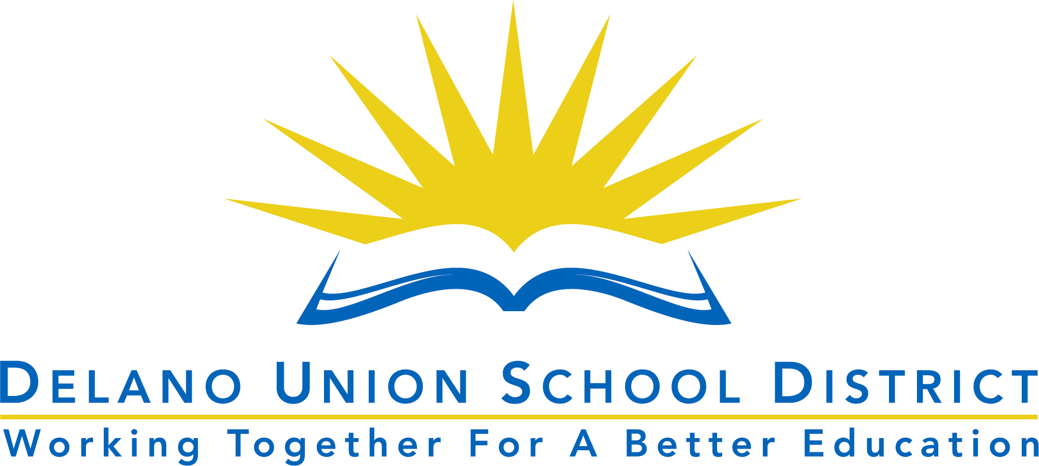DELANO UNION SCHOOL DISTRICT

DUSD Spelling Bee 2024-2025
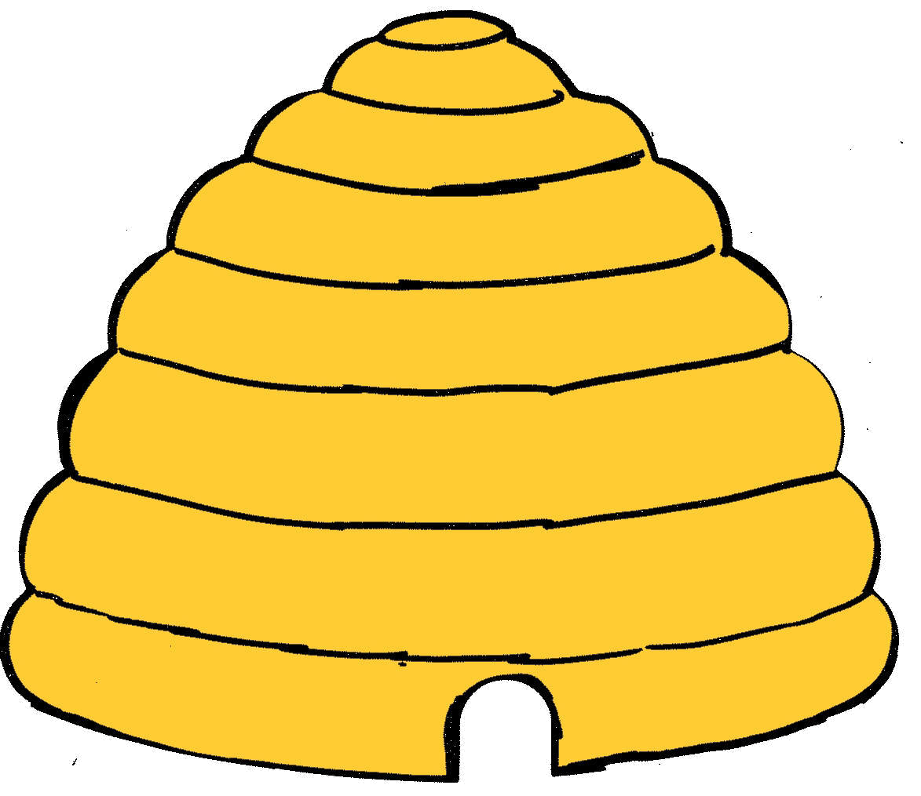

Coach Form
Delano Union School District
Spelling Bee

Please return the typed form by Friday, October 17, 2024 to:

Lea Cantu – Educational Services
1405 12th Avenue Delano, CA 93215
phone: 661-721-5000 ext. 00109 fax: 661-721-3099
e-mail: lcantu@duesd.org

SCHOOL
1. | Name
 | Position
 | Contact#
 | e-mail
2. | Name
 | Position
 | Contact#
 | e-mail
3. | Name
 | Position
 | Contact#
 | e-mail
Revised 10/2024

